Experiment 5.1
Determination and plotting of Electric Potential Difference

Code File Name: Exp5_1_ElectricPotentialDifference.m
Code
clc;
clear;
q=input("Enter the q value:");
epsilon=8.854*10^-12;
k=1/(4*pi*epsilon);
ax=input('Enter the value of ax=');
ay=input('Enter the value of ay=');
r1=sqrt(ax^2+ay^2);
v1=k*q/r1;
disp('The value of v1');
disp(v1);
bx=input('Enter the value of bx=');
by=input('Enter the value of by=');
r2=sqrt(bx^2+by^2);
v2=k*q/r2;
disp('The value of v2');
disp(v2);
v=v1-v2;
disp('The electric potential difference is');
disp(v);
% Plot (manual style)
r = linspace(0.1,10,50);
y = v1*exp(-0.1*r);
z = v2*exp(-0.1*r);
x = v*exp(-0.1*r);
figure;
subplot(1,3,1);
plot(r,y,'LineWidth',2);
title('The potential difference v1');
xlabel('radius 1');
subplot(1,3,2);
plot(r,z,'LineWidth',2);
title('The potential difference v2');
xlabel('radius 2');
subplot(1,3,3);
plot(r,x,'LineWidth',2);
title('The potential difference v');
xlabel('radius');
Command Prompt
Enter the q value:2e-2
Enter the value of ax=1
Enter the value of ay=4
The value of v1
4.3597e+07
Enter the value of bx=36
Enter the value of by=64
The value of v2
2.4480e+06
The electric potential difference is
4.1149e+07
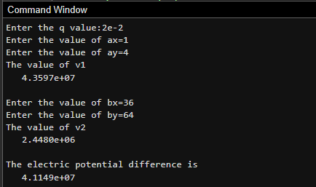
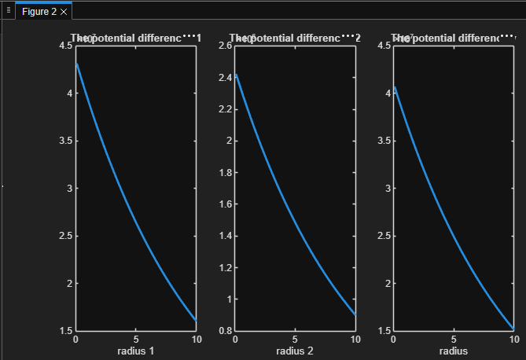
Output Graph

